NOTICE AND CALL OF PUBLIC MEETING
OF THE SCHOOL DISTRICT

Governmental Body: The Board of Directors of the Montezuma Community School District, Montezuma, Iowa.
Date of Meeting: Wednesday, July 29, 2019
Time of Meeting: 6:00 pm, Central Time
Place of Meeting: Montezuma School Elementary Library, Montezuma, Iowa.

PUBLIC NOTICE IS HEREBY GIVEN that the above-mentioned governmental body will meet at the date, time and place above set out. The tentative agenda for said meeting is as follows:

- Call to Order/Roll Call
- Discuss the purchase of a piece of property

This notice is given at the direction of the President pursuant to Chapter 21, Code of Iowa, and the local rules of said governmental body.
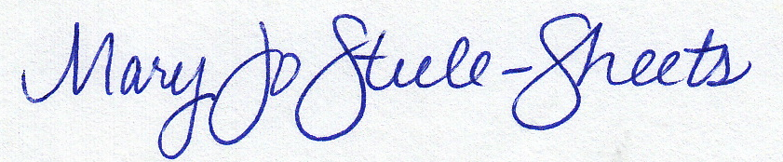
Board Secretary, Montezuma Community School District, Iowa

